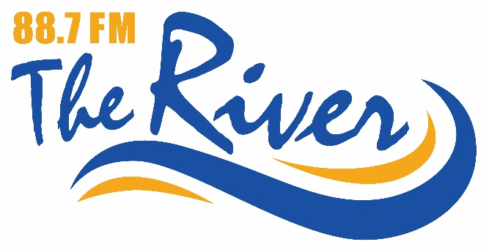

Attention all Chamber Members,
We are excited to announce an amazing offer to ALL Minto Chamber members! We are the new radio station, CIWN, 88.7 The River serving north Wellington County and we want to consider us for your very first radio advertising promotion.
All current Minto Chamber of Commerce members who wish to advertise on 88.7 FM will receive 5% off your first order up to a maximum of $100 off!
For more details, contact Rob Mattice, GM Saugeen Community Radio at 519-509-0887 or you can contact your local Chamber of Commerce.
Don’t miss this opportunity!
Tune in to us while at work at 887theriver.ca.

Rob Mattice
GM/GSM
88.7 The River

