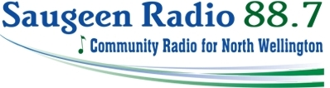

Attention all Chamber Members,
We are excited to announce an amazing offer to ALL Minto Chamber members! We are the new radio station, CIWN 88.7 FM serving north Wellington County and we want to include you in our very first radio advertising promotion.
All current Minto Chamber of Commerce members who wish to advertise on 88.7 FM will receive 5% off your first order up to a maximum of $100 off!
For more details, contact Rob Mattice, GM Saugeen Community Radio at 519-591-7253 or you can contact your local Chamber of Commerce.
Don’t miss this opportunity!
Stay tuned to Saugeen.ca for further updates and to hear about our upcoming “Name that Radio Station contest”

Rob Mattice
GM/GSM
Saugeen Radio Inc.

